**ANT PATH FOLLOWING ROBOT**

[1] SampratiKatariya,[2] ShreyasBhoyar, [3] ShrikantPawar

***Students of Computer Science Department of PimpriChinchwad College of Engineering Pune***

***Under the guidance of Ms. Swati Jaiswal Ma’am***

[*samprati.katariya@gmail.com*](mailto:samprati.katariya@gmail.com)

[*sbhoyar1009@gmail.com*](mailto:sbhoyar1009@gmail.com)

[*Shri13021998@gmail.com*](mailto:Shri13021998@gmail.com)

***Abstract:***

**This paper introduces the complete concept of the Ant Path Following System in our daily lives, we are constantly in need of a machine or program that can stand on its own and perform its functions. In long-distance driving, we tend to get tired and wish our legs were a little more relaxed instead of being in the accelerator all the time, our hands relaxed instead of continuing to control the steering wheel. Following the most important thing does not always have to be considered. There is no need to push the trolley to a factory or supermarket or a baby car. All of these problems and many more can be solved using the line tracker, based on the image processing principle. In this paper, we have tried our hands to make an active line follower robot that uses the line tracking principle. It is different from normal line followers, uses photodiode sensors thus giving it a chance to see the future (e.g. the upcoming line pattern), and is ready to direct that pattern. The other hand above of this design is that you can follow any color line as long as the background has a few bright colors.**

***Keywords:*Arduino, IC L293D, Infrared LED, DC Motor and Proximity Sensor,Q-learning**

1. **INTRODUCTION**

An ant path following a system It is a one-way machine The path can be seen as a black or white line in the white area. The ant that follows the System is a stand-alone Traceable robot black line drawn on the fact that contains a different color.Designed to automatically move and track. The robot uses an LED to indicate a robot. The robot is provided with DC gear Motors to control wheel speed. The vast scope of the problem of finding a way involves efficiency and safety issues. Arduino display typically uses an algorithm to control the speed of the motors directing the robot to move smoothly along the line. In addition, there is an LCD interface that displays the movement of the robot. It can be very useful in the automated management of industrial equipment, small in-house applications, and other similar applications. An ant-trailing method is often used to transport babies to shopping malls, homes, hospitals, and factories.

For understanding the overall functioning of the robot, basic knowledge about the IR or UV sensors, microcontroller, the motor is required.

IR sensor works on the incidence and the reflection of light. The light gets completely reflected in the case of the white surface but partially in the case of a colored surface. When the surface is black, the is completely drawn up as black color absorbs the light. So these principles are used in path detecting. Arduino or any other microcontroller can be used like raspberry pi, PIC.

Autonomous Line Following Robot can be made using image processing, neural networks. The proportional controller is another method to control a line follower method. Recently reinforcement learning is also used for such applications as robotic arms, games. In reinforcement learning an agent takes the decision for which it can be rewarded or penalized. It performs trial and error to come up with the solution. The goal is to maximize the rewards. Q learning is a Reinforcement Learning based method to control the robot. There are two main parts while building a robot, detecting lines and controlling the motor. PWM (Pulse Width Modulation) is an easy technique to control motor.

Autonomous robots can also be used for obstacle detection, for carrying the load in transportation. They are also used in drug delivery. So there is much requirement of such robots nowadays.

1. **BUILDING COMPONENTS**
2. **Arduino**

Arduino is a free and easy platform to use for hardware & software. This platform can use for implementation projects. Each board has the same thing that is a microcontroller. The microcontroller is a small system.In Arduino, the ATmega328 is in use. It has 8 bit CPU specifications, 16 MHZ clock speed, 2KB SRAM 32KB Flash Memory.

Features:

* 14 output-input pins and 11 input-output PWM.
* 6 input pins
* Voltage input from 7 - 12 V

1. **IC L293D:**

This is the motor driver IC used in this project capable of driving on two motors at the same time and The supply voltage is the operating voltage of the motor drive. 6V was used for the DCV motor and the 6 for 12V The gear motor used depends on the size of the system. Reasonable Voltage Determines what type of value is required for the input power to be considered as high or low. Therefore standard power supply is rated at + 5V, then considered as -0.3V to 1.5V input, while in this system 2.3V to 5V input is considered as high voltage. The Enable I and Enable 2 are PWM-powered high-speed inputs and two microcontrollers used in the project and are designed as one is high quality and the other low, so we can say that two identical circuits are used, but the performance of both is different.

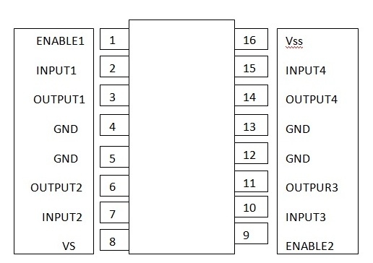

*Fig 1. Pin Configuration IC L293D*

1. **Infrared LED:**

White LED -Transmitter

Black LED - Receiver

LED line sensor (3 LEDs) When the robot hears a straight line the center LED will be turned off and two other LEDs meaning left and right will light up. When the robot hears/turns left the left LED will be switched off and the other two LEDs meaning center and right will light up. Then the robot hears/turns right and the right LED is turned off and the other two LEDs meaning left and one area will light up.

1. **DC Motor:**

A car is a device that mechanically converts any energy force and transmits movement. In making the robot, the car often plays an important role in providing system mobility. In this system in general, a car is operated by a conductor with a magnetic current and current. The current driver usually produces a magnetic field combined with a permanent magnetic field to make the car spin. There are usually three basic types of motors in the system, a DC motor, servomotor, and stepper motor are the most commonly used inthe construction of an ant traffic light.

DC engines are very easy to control. There is one DC car with two performance indicators. Resetting the power supply to it may change the required direction and the speed may vary with the electrical power of the vehicle. A capacitor filter (1000uf) (25v) is used for fluxing (filtering) of the DC output after adjustment to provide a stable DC voltage



*Fig 2. Pin Configuration IC L293D*

1. **Proximity Sensor:**

A proximity sensor is beneficial to provide contactlessobstacle detection and the high response rate of the sensor increases the overall efficiency of the robot. The combination of IR- LED and Photodiode is used as a visual viewing sensor. It causes disruption when the IR beam enters the photodiode. To make the IR break-beam, the IR LED is used with a low value resistor to illuminate brightly. The receiver is a Photodiode that selects 'turn on' whenever IR LED light is available. The IR link is placed next to it and then turned onto produce a pulse in Arduino. The Arduino LCD interface is used to display the integrated range in terms of numbers.

*Fig 3. Pin Configuration IC L293D*

1. **RFID :**

RFID is a technology that stores or encodes digital data in radio-frequency identification, RFID tag or smart label. These RFIDs are displayed on radio waves by an RFID reader. RFID is similar to barcode but has many advantages over barcode technology. The most important advantage is that the RFID tag can read data without focus. Therefore, RFID technology can be used to identify barriers. An RFID program consists of three components: an RFID tag, an RFID reader, and an antenna. The antenna transmits the data to the RFID reader. The reader converts radio waves into data-based channels. The information collected in the tag is transmitted via a visual link found in the capture system.

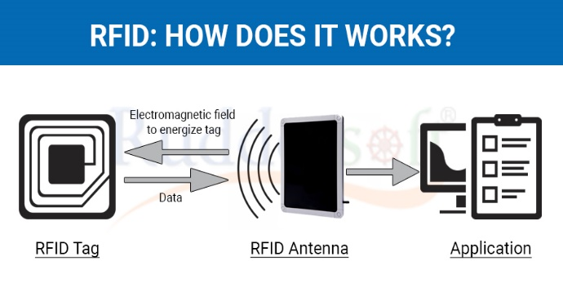

*Fig 4. Pin Configuration IC L293D*

1. **Comparator :**

Comparator is used compare the voltages between the inverting and non-inverting terminals. It is a device that gives a digital signal by comparing two voltages or currents. as an output indicating which is larger. Infrared signal gives output whenever anything comes in between transmitter and receiver. Then comparator sends the desired signals to the controller and controller takes the decision based on input signal.

1. **Interaction of system Component:**

|  |  |  |
| --- | --- | --- |
| Arduino |  | Bluetooth |
|  |  |  |
| RX |  | TX |
| TX |  | RX |
| SV |  | VCC |
| GND |  | GND |

*Fig 6: Arduino Connection with Bluetooth*

Connect the Light-emitting diode refuse to the GND of the Arduino microcontroller & the positive to pin 13 with a resistance value connecting 220 ohms - 1k ohms.

                     Here the Android app is basically used for designed to send serial data to the Bluetooth module at the press of a specific button. The other end receives the Bluetooth module data and sends it to the Arduino via the Bluetooth module's TX pin Arduino's RX pin). If the code 1 received for the Arduino is 1 received data, it will check and compare the received data. (in our case 3) the LED turns on which indicates connectivity, if received data is0 (in our case 4) the LED is turned off which means Bluetooth connectivity is disconnected.

* Open the application
* Scan for the available device
* We can pair the device with a Bluetooth module
* After connection give the command in the app to start the robot

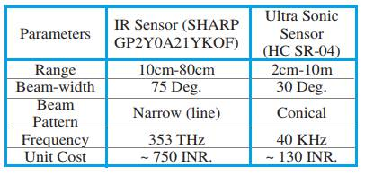

*Fig 5. Comparison of the sensors*

1. **WORKING/ALGORITHM**

The robot follows a white line drawn along the path using an IR sensor. One line follower includes an infrared light sensor and an infrared LED. It works by illuminating the surface with infrared light; The sensor then selects the reflected infrared radiation and, based on its intensity, determines the reflection of the surface in question. This signal is sent to a DC motor operating at a certain speed. This communication is controlled by our microcontroller. There is also a proximity sensor to prevent it from touching the surroundings. This can be done using electromagnetic or electromagnetic radiation beams, in which the field or return signal where the object exists in the surroundings is altered.

Algorithm:

After reviewing and comparing the algorithms we concluded on using the Q-learning algorithm.

The main contribution of this paper is to propose a Q-learning technique to control a basic line follower robot. The basic rules in this paper are applied to follow the simplest path without complicated web like thorns.

The algorithm is based on reinforcement practice.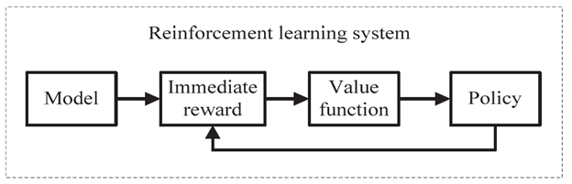

*Fig 7. Reinforcement Learning block diagram*

There are two main types of reinforced learning - Model Based and Model Free, the algorithm mentioned here is Model-Free Learning Algorithm

Q * (s, a) is the expected value (cumulative discount reward) by doing a in the state and then following the correct procedure.

Q-Learning uses the temporal variance (TD) to estimate the value of Q * (s, a). The temporal difference is the agent who learns from the environment through episodes without prior knowledge of the environment. • Agent maintains a table of Q [S, A] where S is the set of states and A is the set of actions.

• Q [s, a] represents your current Q * (s, a) estimate

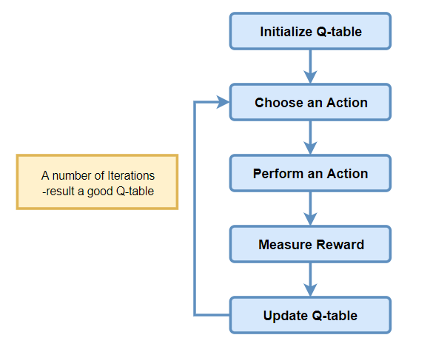

*Fig 8. Q-Learning algorithm block diagram*

**Steps in the algorithm:**

* **Step 1**: Initialize the table: The table is a grid of environments depicted in an* n value depicting the environment present around them.
* **Step 2**: Design actions and enumerate them. For example, for our robot, the actions could be movements right, left, front, etc.
* **Step 3**: On based on the environment and the movement are rewarded based on our intuition.
* For example, since our robot is designed to move in a straight line, the maximum reward is given on forward action.
* **Step 4**: Update the environment matrix based on the rewards gained.

The rewards, in technical terms, is called weights and the environment matrix is called a Q-Table.

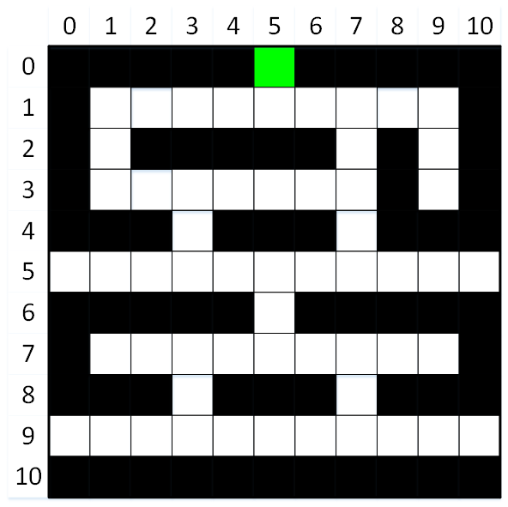

*Fig 10: The path for the robot to move and divided into a matrix*

These values can be calculated by simulation using MATLAB to obtain a minimal Q-Table and update values in real-time.

Once the values are embedded in the microcontroller, the robot works on a greedy approach and finds a way to find a path with maximum weight.

1. **CONCLUSION**

We studied different papers for the topic in which various components were used based on the requirement. In most cases,an IR sensor is used for obstacle detection. The microcontroller is the important part whose choice can be made depending on the application and requirement like the size of code, programming knowledge, on-chip components requirement. If someone wants a robot which that functions well but should be a chip then PIC can be a good choice while Arduino would provide a better interface to code and would not provide a steep learning curve. LDR and IR sensors are most commonly used in line follower robots.

1. **REFERENCES**

[1] P. S. Milan, Santosh, S. Das, H. S. Bhanu, “A Review on Self-Balancing Line follower Robot “, *International Journal of Engineering Research & Technology (IJERT),* January 2021

[2] V. Barua, A. Pathak, Nahar, “An Ultrasonic Line Follower Robot to Detect Obstacles and Edges for Industrial and Rescue Operations”, *International Journal of Computer Applications*, June 2020

[3] Q. T. Sadat, S. K. Rahman, T. E. Nur, N. S. Ferdous, “Design and Implementation of Line Follower Robot using Arduino Microcontroller”, *International Journal of Scientific & Engineering Research*, April 2020

[4] J. Chaudhari, A. Desai, S. Gavarskar ” Line Following Robot Using Arduino for Hospitals”, *International Conference on Intelligent Communication and Computational Techniques (ICCT)*, September 2019

[5] W.H.M. Saad, H.R. Ramli, R. Marimuthu, S.A.A Karim, Z. Manap,” Development of Line Follower Robot with Camera Surveillance System”, *International Journal of Recent Technology and Engineering (IJRTE)*, November 2019

[6] B. N.Mohapatra, K. U. J. Husain, R. K. Mohapatra, ”Implementation of a Line Follower Robot using Microcontroller”, *International Journal of Innovative Technology and Exploring Engineering (IJITEE)*, December 2019

[7] M. Srilekha, N. Fathima, G.Anusha, D. S. Chary “Line Follower Alphabot Using Arduino Micro Controller”, International Journal of Engineering Research in Electrical and Electronic Engineering (IJEREEE), February 2018

[8] R. K Sure, S. Patil, “Android Based AutonomousColoured Line Follower Robot”, *International Journal of Research in Engineering and Technology(IJRET),*eISSN: 2319-1163

[9] S. Shamikh M. Husaini, S. Mohammad Hamza, M. Saalim, “A Comparison based Line Following Robots Design for Path Planning and Maze Solving”, *International Research Journal of Engineering and Technology (IRJET)*, Sep 2020

[10] A. Khalique, Muhammad Iqbal Bhatti “Command Based Line Following Robot using RF Technology” *Journal of Advanced Computer Science and Technology Research, 2011*

[11] K.Akka, FaridKhaber“ Mobile Robot Path Planning using an Improved ant colony Optimization”, *International Journal of Advanced Robotics System (IJARS)*, 2018

[12] Y. Wang, Weixiang Zhou “Reliable Intelligent Path Following Control for a Robotic Airship Against Sensor Faults” *Institute of Electrical and Electronics Engineering (IEEE)*, 2019

[13] D. Liu, HanXvSun, QingXuanJia “Stabilization and Path Following of a Spherical Robot” *Institute of Electrical and Electronics Engineering (IEEE),* 2018

[14] Y. Tao,“A Mobile Service Robot Global Path Planning Method Based on Ant Colony Optimization and Fuzzy Control*“ Institute of Electrical and Electronics (IEEE)*, 2021

[15] A.Hassanein; M. Elhawary “Robot Path Planning using An Ant Colony Optimization Approach: A Survey” International Journal of Advanced Research in Artificial Intelligence(IJARAI)